- ROY AND HIS PROFILE PICTURE
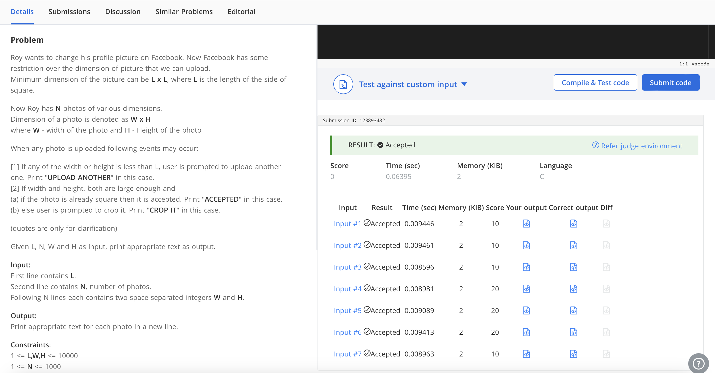

- ZOO PROBLEM
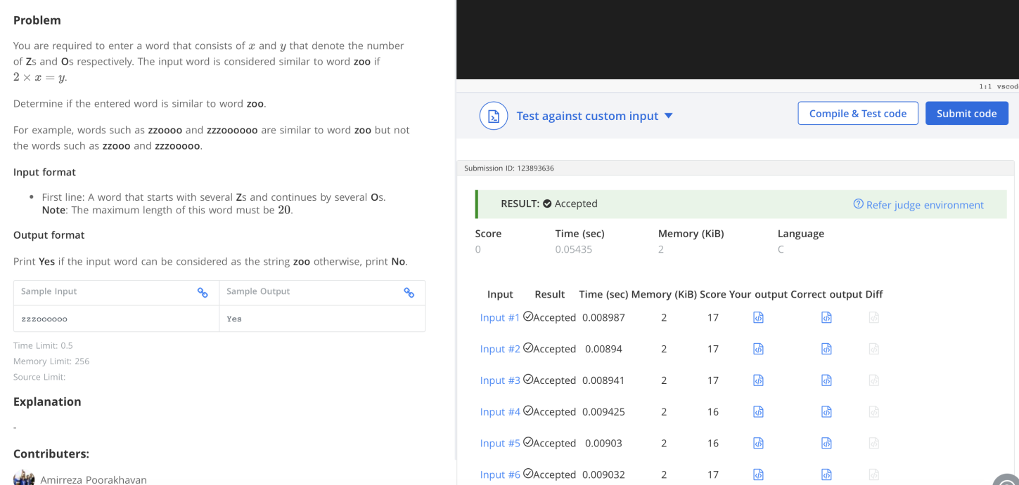

- COST OF BALLONS
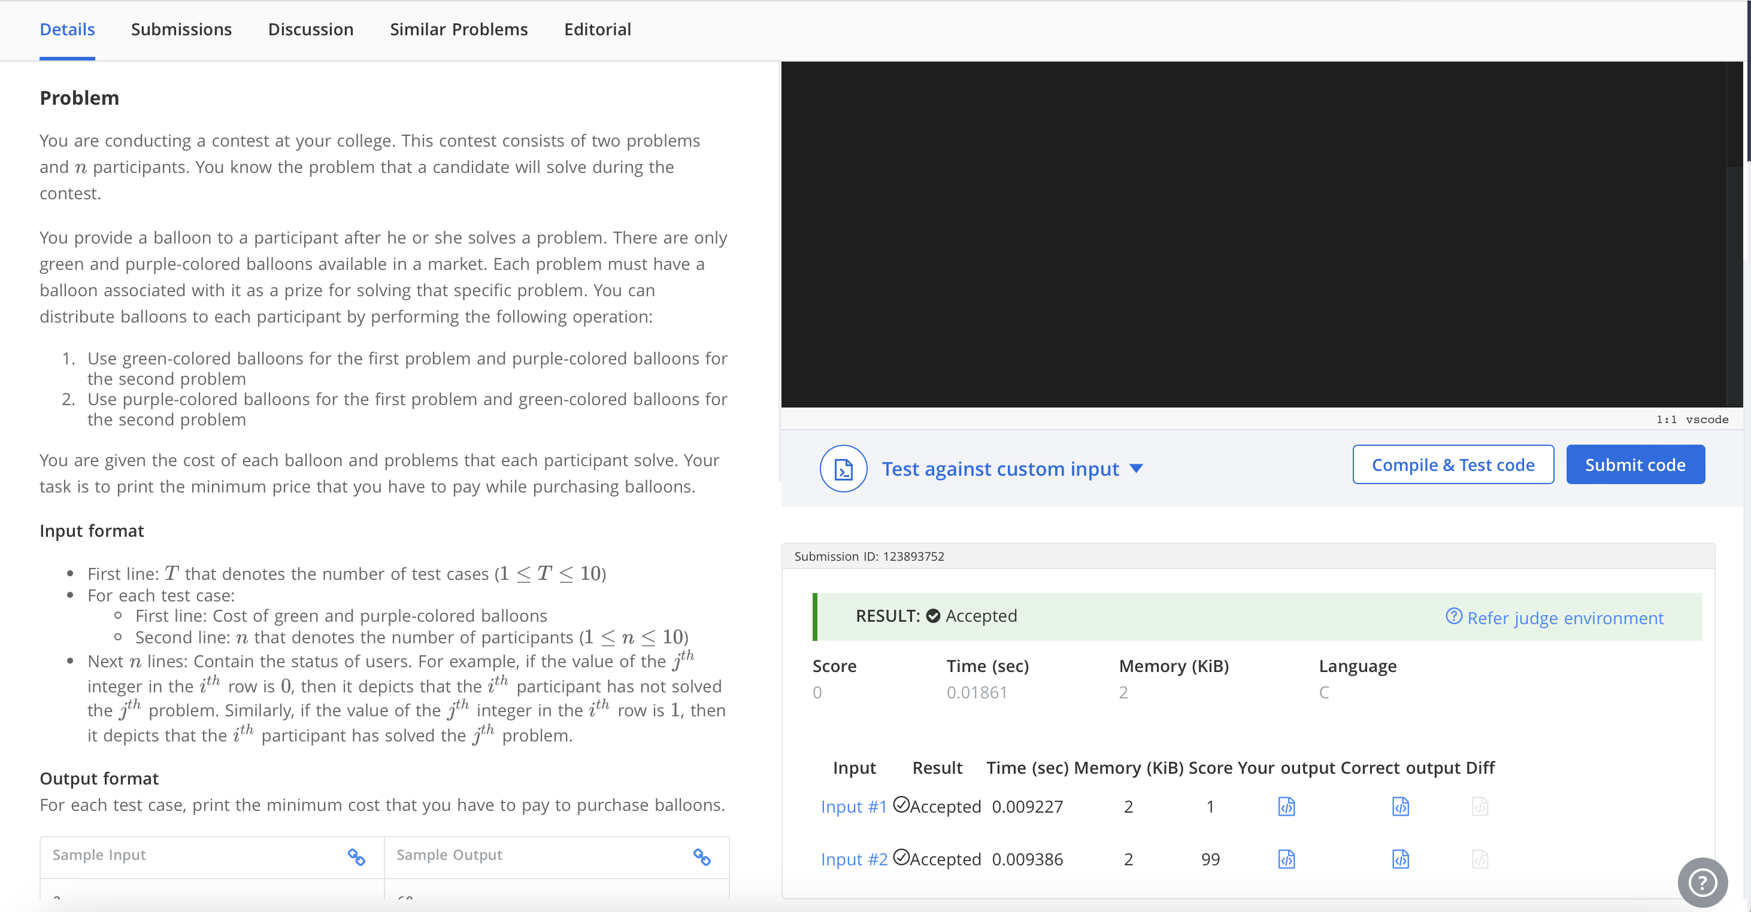

- TOGGLE STRING
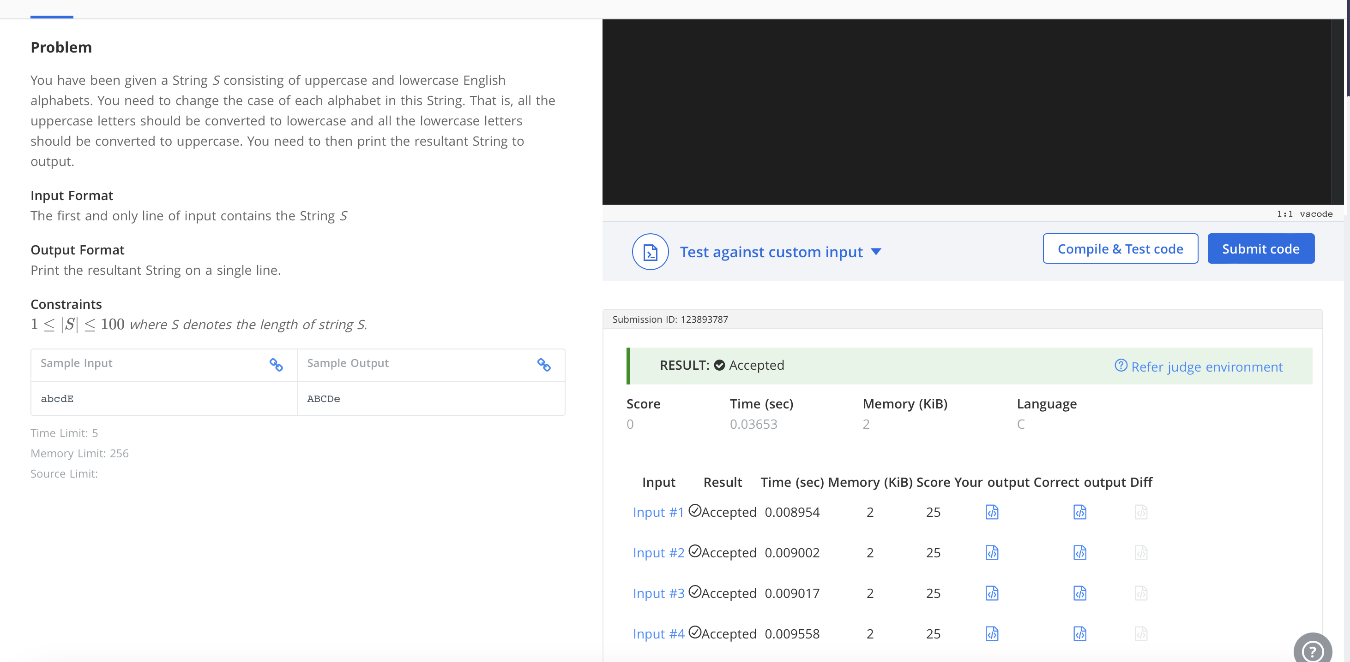

LEETCODE PROBLEMS
- INSERT POSITION
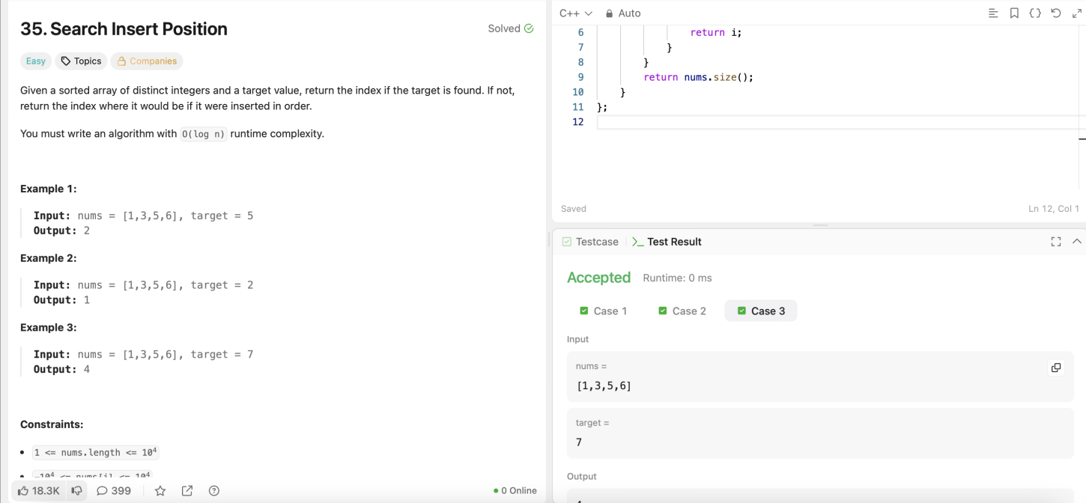

- SINGLE NUMBER
